**Vehicle Performance Report**

**Section 1: Analysis**

**Loading and Unloading Location:** In just 13 days (5th July to 17th July) we have done 207K (0.21M) Logs shifting from Loading Locations CJ16 and CJ05 through Unloading Locations by local and by roadway.

**CJ16:** In which, the logs loading from CJ16 location contains 166K (0.17M) in which the unloading location method was used as by Roadway (1,40,291 logs) and by Local (25,534 logs). The Graph is also being presented below.

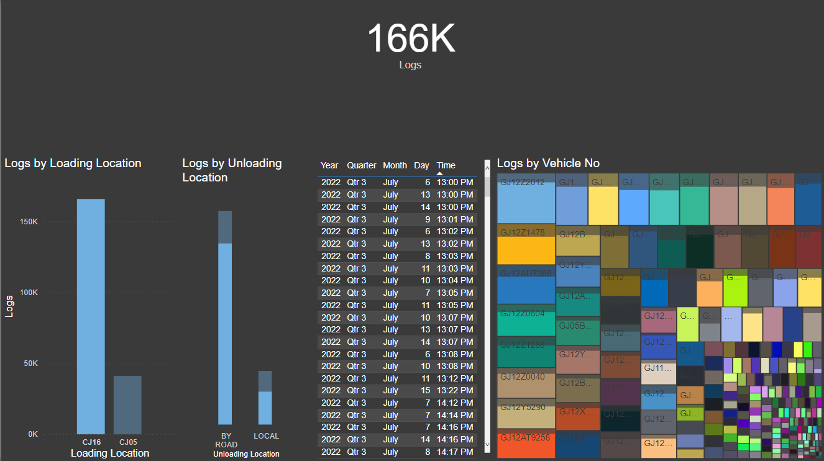

**CJ05:** In which, the logs loading from CJ05 location contains 41K in which the unloading location method was used by Roadway method (25,082 logs) and by local (16,016 logs). The Graph is also being presented below.

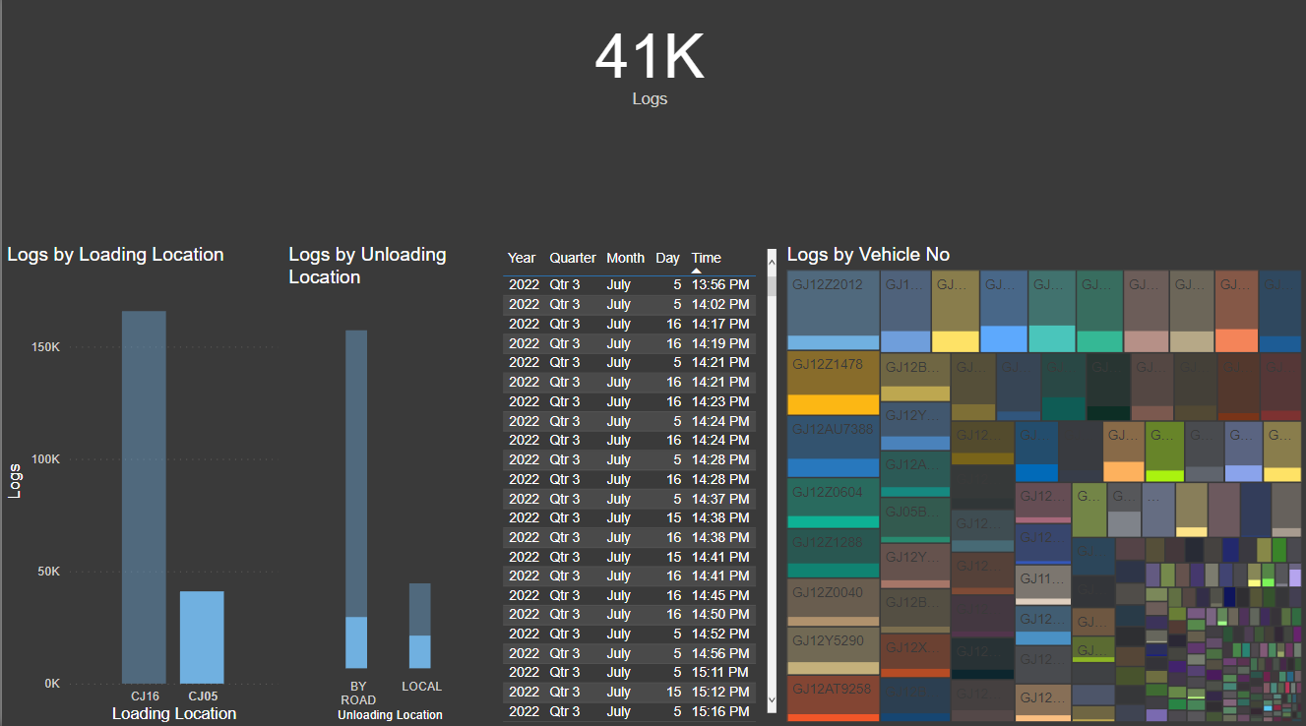

**Section 2: Problems and Solution**

**Problems:**



1. **Data Keeping:** Data Keeping was the major issue in this entire project work as inappropriate data keeping method disturbs the whole analysis.



1. **Incomplete Information:** As per the famous above quote, the incomplete information is also dangerous as by that we can’t get the clear understanding.

**Solutions:**

1. **Driver:** There was no information of drivers. As the vehicle efficiency is also depended upon driver’s capability, experience and wages.
2. **Transporter:** The Transporter’s Information was inappropriate.
3. **Unloading:** The unloading location was only described as by Road and by local instead of giving the proper location.
4. **Time:** There was missing time from other side i.e., from and to. There was only given **from time** but not the **to time.** As a result, we can’t find the each vehicle’s trip turnover time.

**Section 3: Conclusion**

We have been provided the information of **“MV African Rook V47 Final Shifting Reports”** in that **“Log Shifting Report”** from July 5 to 17, 2022, by Santosh Sir. On that basis, I have prepared an excel file **“Vehicle Performance Report”** which shows every vehicle performance which differentiates by carrying the logs, no. of trips taken, in how many days and length by each vehicle. Alongwith this, I generated the Average also of Trips/day and Length/Trips.

As per my understanding and knowledge, I generated this report. I tried to analyse your data to give you the meaningful insights.